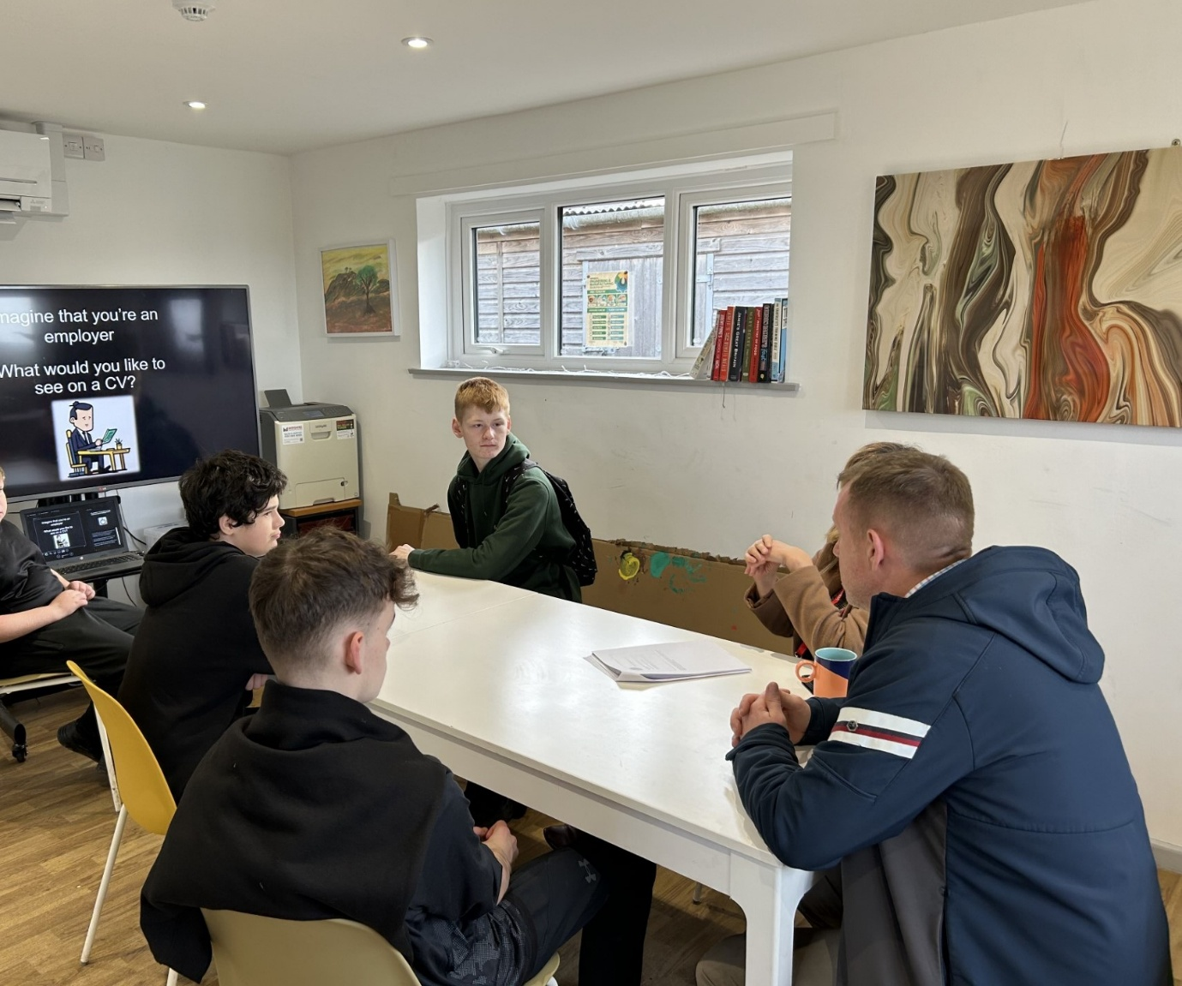
Careers Programme
​"The learners were respectful and focused, having fun learning about writing CVs. They interacted well, demonstrating good listening skills and understanding of the content."
Claire Gilkes, Schools Adviser
DWP Job Centre Plus
Our Careers Programme offers a variety of interactions with role models, inspiring speakers, employers and further education providers, including College Taster Sessions, work-related courses and work experience activities.
PSHE
At Woodlands, we use Jigsaw PSHE lessons, which also help support our learners to develop their Social and Emotional Learning. The Jigsaw PSHE lessons that help deliver careers education are identified within our Careers Programmes for Key stages 3 and 4. See the link below for the Jigsaw website.
- Jigsaw PSHE The Mindful Approach to PSHE, Well-Being, SEL
Branch activities
During Branch sessions, our learners take part in discussions and debates, watch or read news reports and have one-to-one and group meetings to discuss their personal progress, using their Person-Centred Plans (PCPs).

​
Subject specific careers information
Around the school, subject areas display and refer to information about careers related to that subject, as well as labour market information. Many thanks to the Marches Careers Hub for supporting our learners and staff with up-to-date, relevant information resources. Please see the link below.
- Careers & Apprenticeships in Herefordshire, Shropshire and Telford & Wrekin (marchescareershub.co.uk)
Please see the two links below for advice and support.
- Careers advice - job profiles, information and resources | National Careers Service
- icould - Career ideas and information for your future
​

​
​​​​​​​Gatsby Benchmarks
​The Gatsby career benchmarks are predominantly used as a robust framework for developing career guidance in schools that is world-class.
We recognise that effective careers guidance is the driving force to securing futures. We want young people to fully understand the world of possibilities out there and make the most of their talents and create lasting careers.
We use the Compass tool to help us to audit our progress in meeting the Gatsby benchmarks. This is reviewed termly. Please click on the links below for the Gatsby Benchmarks.
- Gatsby Benchmarks | The Careers and Enterprise Company
- Gatsby Benchmarks

